Tugas Jurnal 01

Faiq Athif Nurrahim Hadiko – 607062330082

<https://github.com/fqathf/Jurnal01_4701>

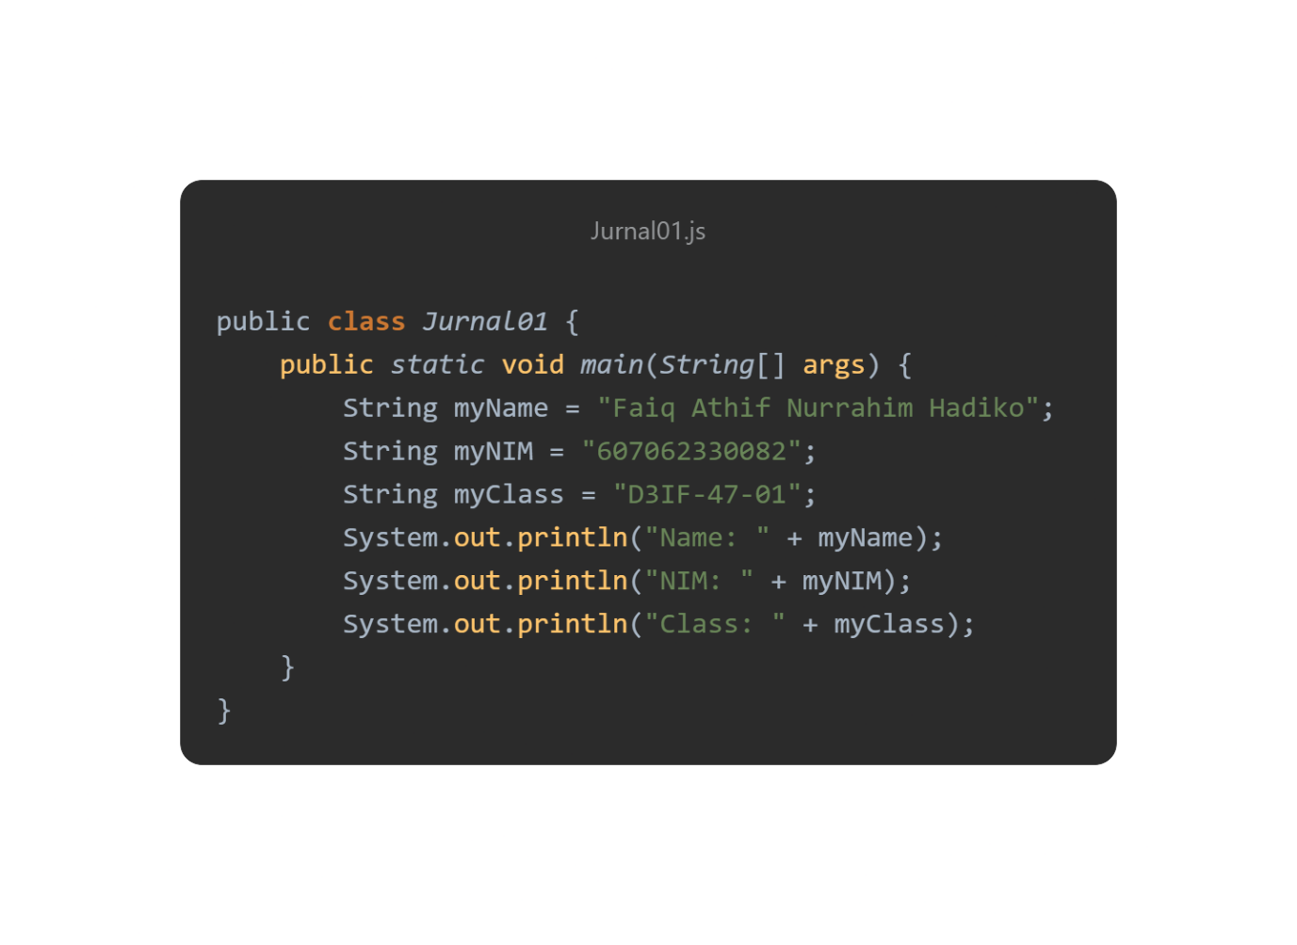

**Output:**

